National University of Computer and Emerging Sciences



Lab Manual # 04

Programming Fundamental

(CS118)

|  |  |
| --- | --- |
| Course Instructor | Mr. Usama Hassan Alvi |
| Lab Instructor(s) | Aqib Zeeshan |
| Section | BCS-1E |
| Semester | Fall 2024 |

Department of Computer Science

FAST-NU, Lahore, Pakistan

**Table of Contents**

Problem 1: Sorting 4 numbers 3

Problem 2: Leap Year 3

Problem 3: Digits Manipulation 3

Problem 4: Right Angle Triangle 3

Problem 5: Mini caluclator 3

Problem 6: In order or not in order 4

Problem 7: Armstrong number 4

Problem 8: Check Character . 4

Problem 9: Write Output. 4

|  |  |
| --- | --- |
| Problem 1: Sorting 4 numbers |  |

Write a C++ program that takes 3 numbers as an input from user. You are required to sort them by printing them in ascending order.

**Sample output:**

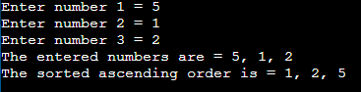

|  |  |
| --- | --- |
| Problem 2: Leap years |  |

Leap years have 366 days (29 days in February). Any year that is divisible by 4 but not by 100 is a leap year. If a year is divisible by 400 then it is also a leap year. So, in short, any year that is divisible by 4 is a leap year, unless it is divisible by 100, in which case it must also be divisible by 400 for it to be a leap year.

Example: 1996 and 2000 were leap years, but 1900 was not.

Write a C++ program to determine if a year input by a user is a leap year or not.

|  |  |
| --- | --- |
| Problem 3: Digits Manipulation |  |

Part (A)

Write a C++ program that takes a 4-digit number from user and prints the digits of the number in English.

If input is 8923 then output should be Eight Nine Two Three.

Part (B)

Design a C++ program that takes a 4-digit number as input and it prints the count of all digits (0 to 9) only if the digits count is greater than zero.

|  |  |
| --- | --- |
| Problem 4: Right Angle Triangle |  |

Write a C++ program that prompts the user to enter the lengths of three sides of a triangle and then outputs a message indicating whether the triangle is a right triangle.

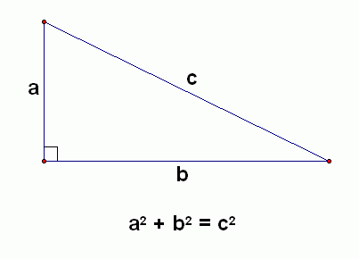

|  |  |
| --- | --- |
| Problem 5: Count input digits |  |

Design a C++ program that works like a mini calculator. That shows the menu like this

Enter '+' for addition

Enter '-' for subtraction

Enter '*' for multiplication

Enter '^' for square

Get choice from user. Must accept a valid choice.

Then get two numbers from user and perform that actions and show the result.

|  |  |
| --- | --- |
| Problem 6: In order or not in order |  |

Write a C++ program that reads in three integers and prints “in order” if they are sorted in descending then **“in order**, or “**not in order**” otherwise. Also tell the original order of the input numbers.

The sample output is given below:

# 1 2 5 not in order

# 1 5 2 not in order

# 5 2 1 in order

1 2 2 not in order

|  |  |
| --- | --- |
| Problem 7: Armstrong number |  |

A number is Armstrong number if the sum of the cubes of its digits is equal to the number itself. For example, 371 is an Armstrong number since 3*3*3 + 7*7*7 + 1*1*1 = 371.

You should write a program which asks user to enter a number and your program should check whether the number is Armstrong or not.

|  |  |
| --- | --- |
| Problem 8: Check Character. |  |

[Write a C program to check whether a character is alphabet or not.](https://codeforwin.org/2015/05/c-program-to-check-alphabet.html)

|  |  |
| --- | --- |
| Problem 9: |  |

Determine the output of each variable at each line.

Int main ()

{

int x = 0;

int y = 5;

int z = 1;

x++;

y -= 3;

z = x + z;

x = y * z;

y %= 2;

z--;

}